Applied Mathematics and Computational Biology
CNRS UMR 8542
ÉCOLE NORMALE SUPÉRIEURE

David Holcman, PhD
Director of Research CNRS
Group of Applied Mathematics and Computational Biology
46, rue d'Ulm
75005 Paris, France
Tél + 33 (0)1 44 32 36 61
Paris, Sept 25nd 2023
Research period: Position available
The groups of D. Holcman (ENS) dedicated to Applied Mathematics and Computational biology in collaboration with Dr. D. Menassa (University of Oslo/University of Oxford/University of Southampton) offer a joint training period at a Master level. Fields covered are image and signal processing, applied math, classification methods to identify from several imaging migratory routes of microglial cells in the embryo.
Title: Image processing, modeling and data classification to study the spatial organisation and migratory routes of microglial cells in the embryo
Project:
Background
Microglia are the resident macrophages of the brain and play pivotal roles in synaptic pruning, clearing debris, wiring of neuronal circuits and myelination. The growth of the population is speculated to follow a similar timeline as in rodents though much is needed to characterize the precise cell dynamics.
Aims
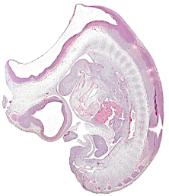
The aim of this project is to use labelled tissues across the entire embryo in the sagittal plane, to provide a spatiotemporal characterisation of migrating versus non-migrating cell distributions within and between different stages. Using Machine-learning and image processing, we will identify the population grows from one stage to the next by looking at proliferation. Because these cells enter the brain from the periphery, we will use the present classification to identify routes of entry into the forebrain, midbrain and hindbrains.
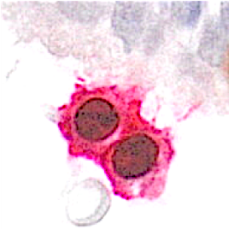
example of image to analyse are shown in the left: Microglia/Proliferation.
Outcome
This research will clarify the spatiotemporal distributions of the cells using an unbiased mathematical approach. The classification approach will be used result to study how cell destination depends on morphogenic gradients.

Duration: at least 6 months.
Candidate: The candidate for this position is expected to be strongly motivated by signal processing and medical sciences. He/she should have a background in applied mathematics. The candidate should be passionate by her/his research. Students are encouraged to write a publication at the end of the training period. We strongly encourage student motivated to continue on a PhD thesis. Both groups have a strong tradition in training students that are joining top international institutions.

Contact information:
David Holcman 46, rue d’Ulm, 75005 Paris France Email: david.holcman@ens.fr and David Menassa <david.menassa@queens.ox.ac.uk>

