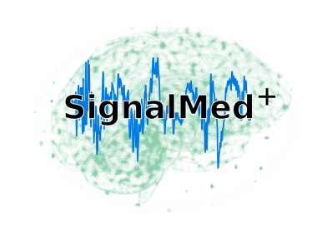**Applied Mathematics and Computational Biology**

**CNRS UMR 8542**

**ÉCOLE NORMALE SUPÉRIEURE**

**And SignalMed+**

**Developing an intelligent predictor of the brain during anesthesia based on learning and control strategy**

**Background**: Although the brain activity is routinely monitored by electro-encephalogram (EEG), anesthesia overdose can happen and is considered as a serious brain state that can lead to post-anesthetic complications. In the past years, we have developed signal processing algorithms coupled to ML-classification approaches to prevent deep sedation based on the first 10 minutes. We isolated predictive patterns that can be used to prevent over-sedation [1-4] in real-time.

**Goal: T**he goal of this internship is todevelop a control system that maintains the brain in an ideal optimal state. We propose to build an automated controller, based on learning strategy associated with the brain response to changes the doses. We will develop a real-time algorithm and a predictive index for post-operative complication, based on EEG spectral decomposition to estimate the brain response probability to changes of concentration.

**References:**

[1] Cartailler et al*, Alpha rhythm collapse predicts iso-electric suppressions during anesthesia, Communications Biology* (2019).

[2] Sun & Holcman, , Biomedical Signal Processing and Control (2022).

[3] C Sun, D Longrois, D Holcman, [Spectral EEG correlations from the different phases of general anesthesia](https://scholar.google.com/citations?view_op=view_citation&hl=en&user=E73vfy8AAAAJ&sortby=pubdate&citation_for_view=E73vfy8AAAAJ:PkcyUWeTMh0C), Frontiers in Medicine 10, 1009434

[4] V Loison, et al, [Mapping general anesthesia states based on electro-encephalogram transition phases](https://scholar.google.co.uk/citations?view_op=view_citation&hl=fr&user=E73vfy8AAAAJ&sortby=pubdate&citation_for_view=E73vfy8AAAAJ:aIdbFUkbNIkC) bioRxiv, 2023.07. 06.547567

[5] Chris Sun, I Constant, D Holcman, [Predicting sensitivity to general anesthesia: Bispectral index versus Checkpoint-Decomposition Algorithm](https://scholar.google.co.uk/citations?view_op=view_citation&hl=fr&user=E73vfy8AAAAJ&sortby=pubdate&citation_for_view=E73vfy8AAAAJ:65Yg0jNCQDAC), medRxiv, 2023.05. 03.23289473

**Candidate**: The candidate should be highly motivated, interested in Signal processing, spectral decomposition, ML, data analysis, inferences, control theory, software engineering and medical science. A strong problem solving and analytical mindset, as well as attention for code quality are necessary. A strong background in Python and computer engineering (communication protocols, operating systems), and web apps is expected. Ideally, the candidate would be familiar with version control systems (e.g Git) and have an understanding of signal processing (eg Fourier transform).

**Where**: The internship position will take place at ENS and SignalMed+, a recent start-up company, in collaboration with the Group of Applied Mathematics and Computational Biology at École Normale Supérieure in Paris, 46 rue d’Ulm, France directed by D. Holcman.

**Internship type**: Master internship, engineering.

**Duration**: 6 months🡪 possibility to continue for a Phd/Postdocs

**Supervisor**: Juergen Reingruber/ David Holcman/

**Contact information**: reingrub@bio.ens.psl.eu and [david.holcman@ens.fr](mailto:david.holcman@ens.fr)